
DEPARTMENT OF COMPUTER SOFTWARE ENGINEERING
MILITARY COLLEGE OF SIGNALS, NUST
DATA STRUCTURE AND ALGORITHM LAB

OPEN-ENDED LAB
Submitted To | Ma’am Aqsa
Course | BESE 30-A
Date | 17 November 2025
Group Members:
- NC Ibrahim Muhammad Abbas
- ASC Muhammad Maaz Saqib

Library Management System - Comprehensive Technical Documentation
Section | Page | Content Description
1. Introduction | 3 | System Overview & Objectives
2. System Architecture | 4-5 | Class Diagram & Relationships
3. Core Classes | 6-7 | Book, User, Node Implementation
4. Data Structures | 8-9 | Doubly Linked List Implementation
5. Algorithm Templates | 10-11 | Search & Sort Template Design
6. Book Management | 12-14 | Book Operations & File Handling
7. User Management | 14-16 | User Operations & File Handling
8. Borrow/Return System | 16-19 | Transaction Management
9. Main Program | 19 | Menu System Integration
10. Testing Methodology | 20-25 | Test Cases & Results
11. Conclusion | 25 | Summary & Future Enhancements

Index
1. Introduction:
1.1 System Overview:
The Library Management System is a comprehensive C++ application designed to automate library operations, including book cataloging, user management, and transaction processing. The system implements object-oriented programming principles with efficient data structures and algorithms.
1.2 Key Objectives:
- Provide efficient book and user management
- Implement robust borrow/return functionality
- Ensure data persistence through file handling
- Optimize search and sort operations
- Maintain transaction history with timestamps
1.3 Technical Requirements that are applied:
- C++ Programming Language
- Object-Oriented Design
- Doubly Linked Lists for data storage
- Binary Search for efficient searching
- Insertion Sort for data organization
- File I/O for data persistence

2. System Architecture:
2.1 Class Relationship Diagram
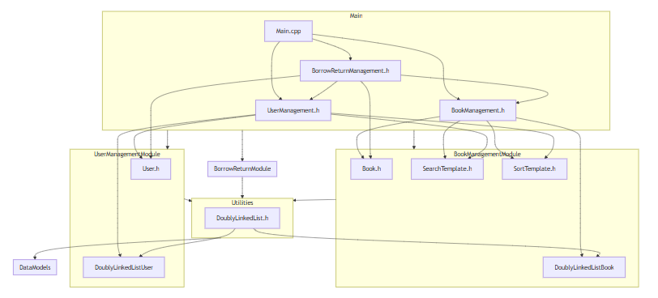
Main Program
│
├── BookManagement ────── DoublyLinkedList<Book>
│ ├── uses: SearchTemplate<Book>
│ └── uses: SortTemplate<Book>
│
├── UserManagement ────── DoublyLinkedList<User>
│ ├── uses: SearchTemplate<User>
│ └── uses: SortTemplate<User>
│
└── BorrowReturnManagement
├── inherits: Book
├── inherits: User
├── uses: BookManagement
└── uses: UserManagement
2.2 File Structure
text
Library Management System/
|__ Swark-output (For Class Relationship diagram)
├── Book.h
├── User.h
├── DoublyLinkedList.h
├── SearchTemplate.h
├── SortTemplate.h
├── BookManagement.h
├── UserManagement.h
├── BorrowReturnManagement.h
├── Main.cpp
├── books.txt
├── users.txt
└── transactions.txt (auto-generated)

3. Core Classes Implementation:
3.1 Book Class:
Key Components:
- Attributes: title, author, ISBN, availability status
- Methods: Constructors, getters/setters, display, comparison operators
Explanation:
- Encapsulation: All data members are protected with public interfaces
- Constructor Overloading: Default and parameterized constructors
- Comparison Operators: Enable sorting and searching operations
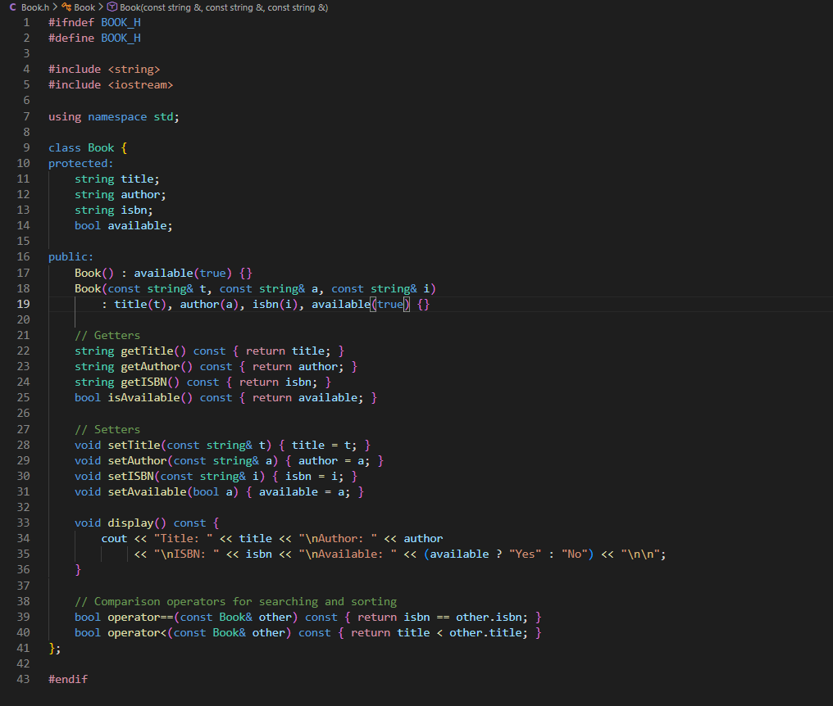
3.2 User Class
Key Components:
- Attributes: ID, name, contact information
- Methods: Constructors, accessors, display functionality
Explanation:
- Unique Identification: User ID ensures each user is distinct
- Contact Management: Stores user contact information
- Operator Overloading: Enables comparison for searching
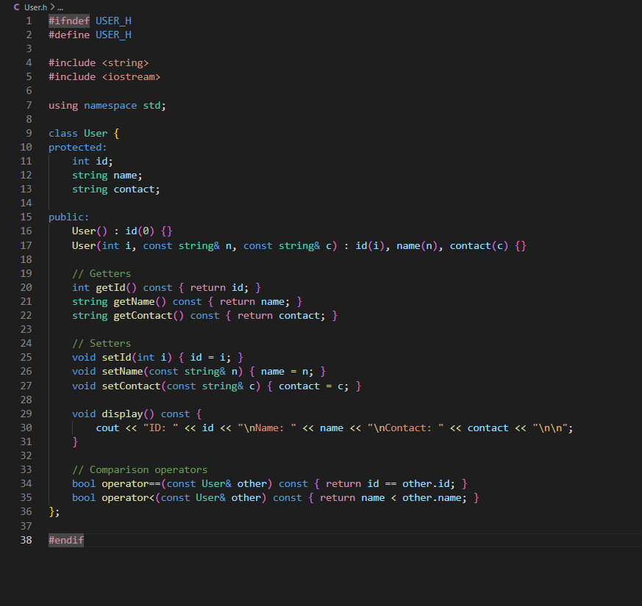
4. Data Structures Implementation:
4.1 Doubly Linked List:
Key Features:
- Dynamic Memory Allocation: No fixed size limitations
- Efficient Insertion/Deletion: O (1) operations at ends
- Bidirectional Traversal: Flexible data access
Algorithm Complexity:
- Add Operation: O (1) - constant time
- Remove Operation: O(n) - linear search required
- Memory Usage: O(n) - proportional to elements
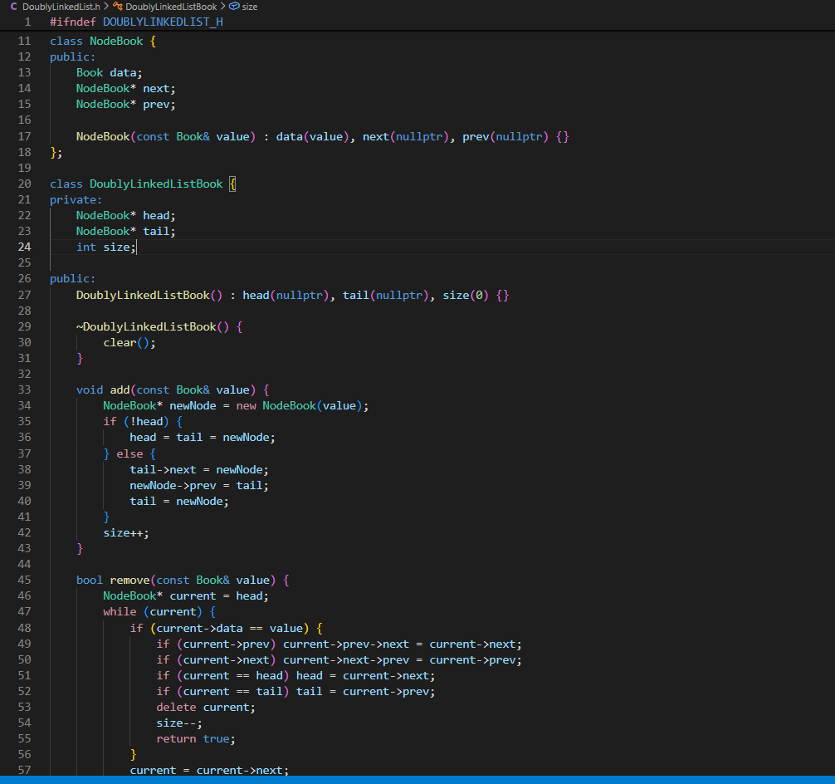
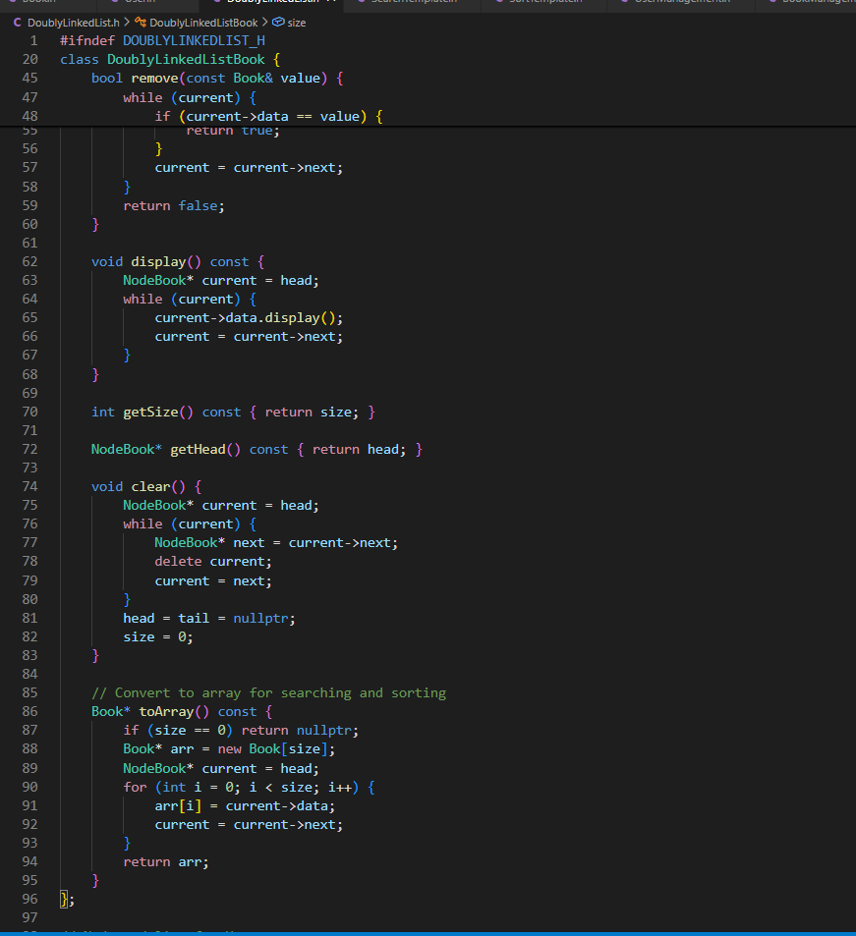

5. Algorithm Templates:
Binary Search Implementation:
Key Features:
- Generic Implementation: Works with any data type and key
- Lambda Support: Flexible key extraction using std::function
- Efficiency: O (log n) time complexity
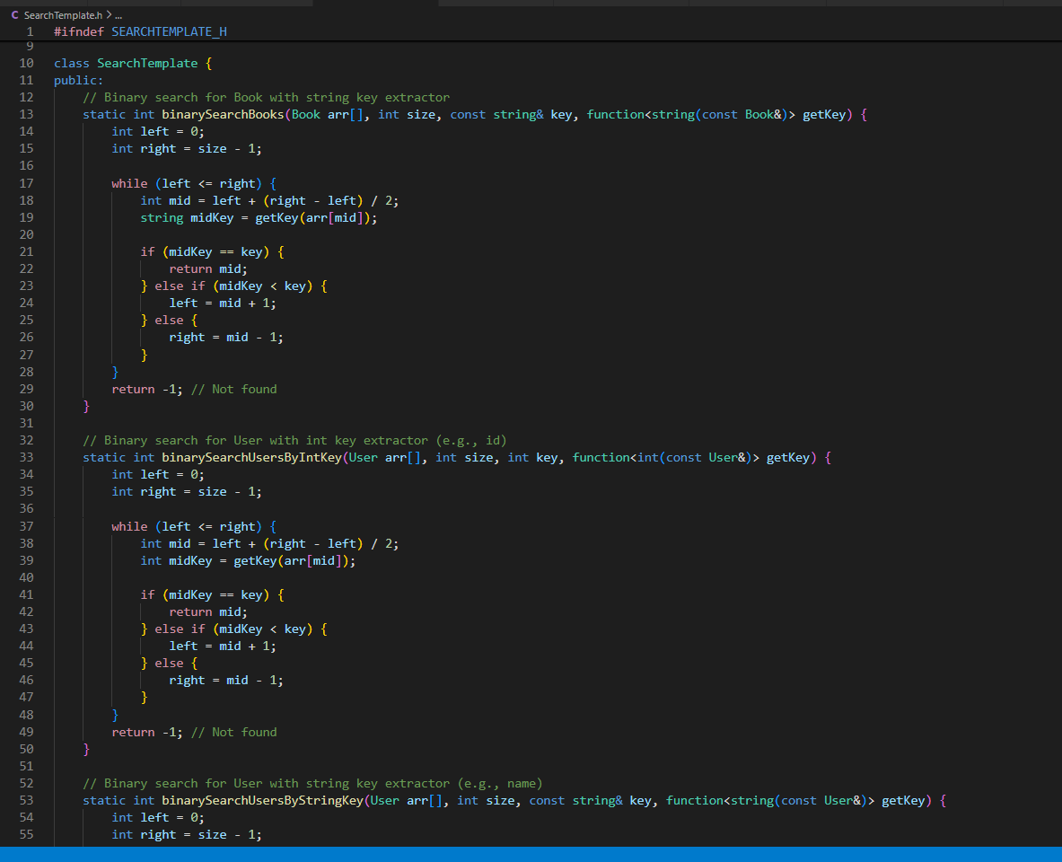
Insertion Sort Implementation:
Algorithm Characteristics:
- Stable Sort: Maintains relative order of equal elements
- Adaptive: Efficient for partially sorted data
- In-place: Requires only O(1) additional memory
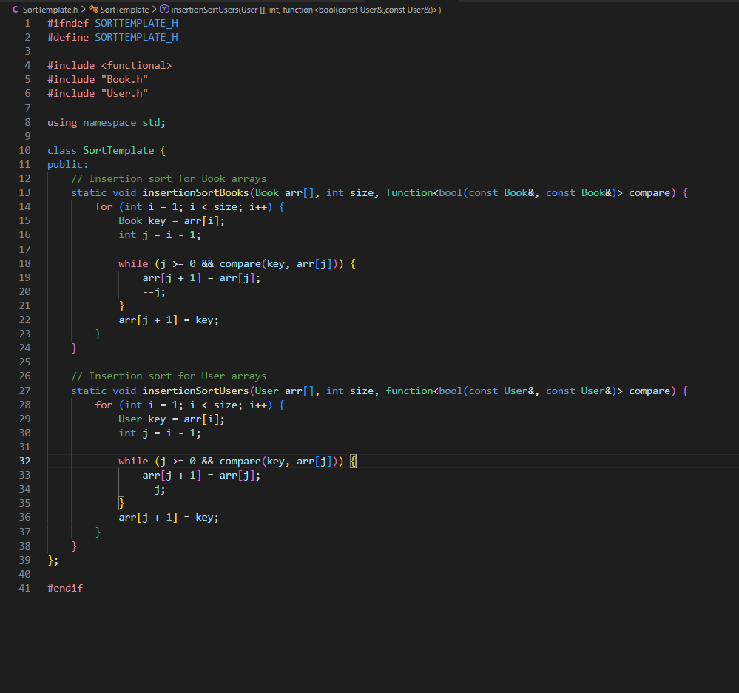

6. Book Management System:
6.1 File Handling Implementation:
Data Persistence Design:
Explanation:
- Automatic Loading: The Constructor automatically loads existing data
- Error Handling: Graceful handling of missing files
- Data Integrity: Maintains availability status
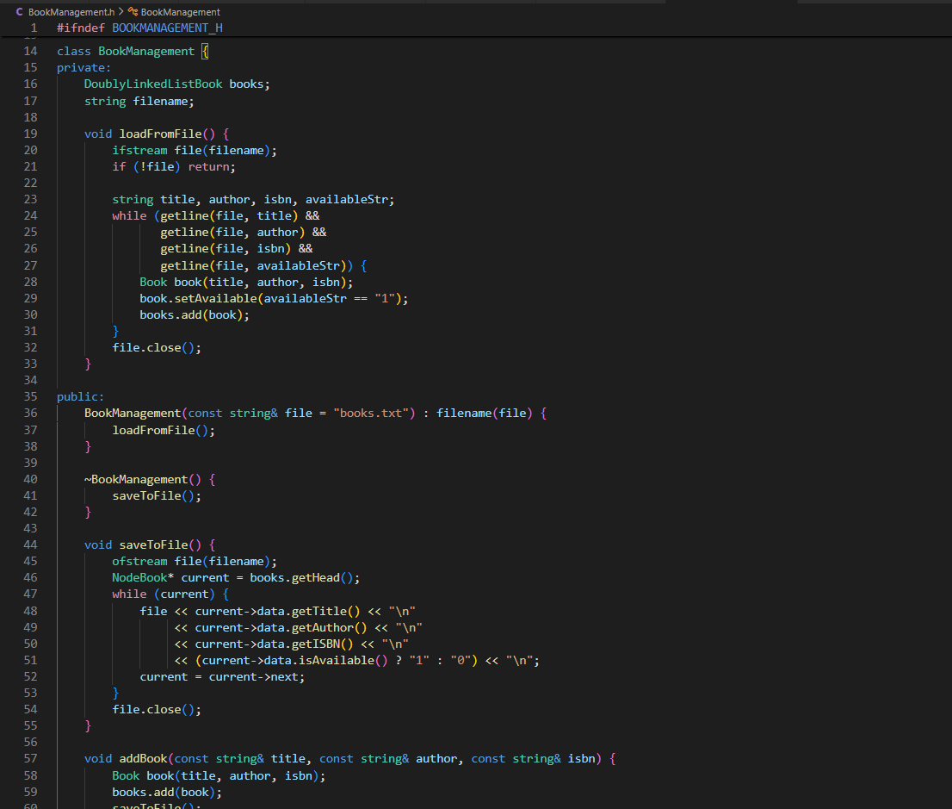
ADD Book:
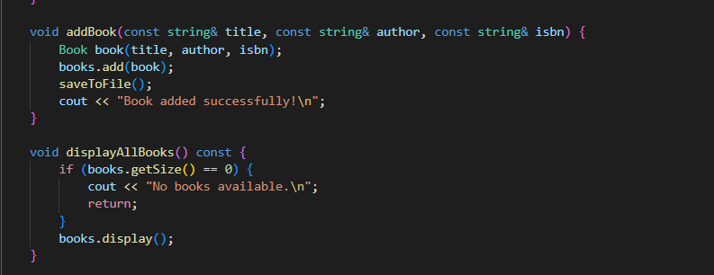
6.2 Search Operations:
Multi-criteria Search Implementation:
Search By ISBN:
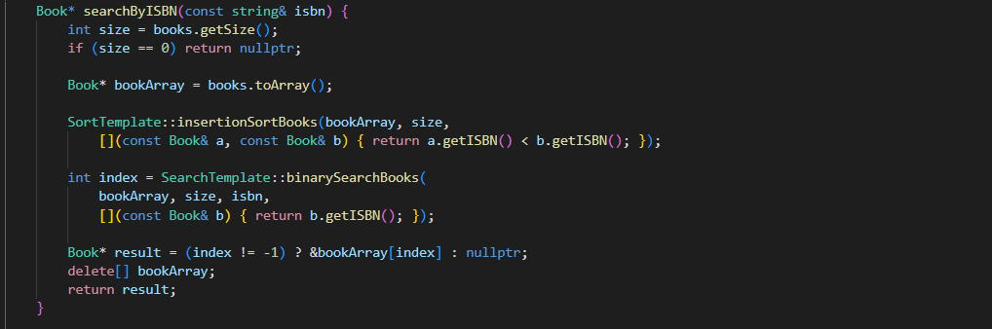
Search By Title:
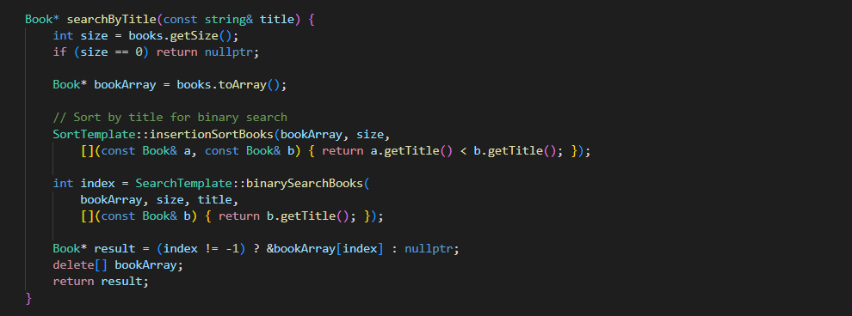
Search By Author:
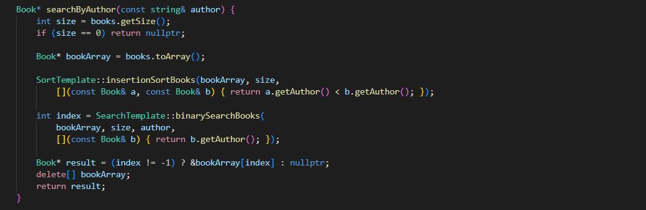
Search Capabilities:
- By Title: Alphabetical search using book titles
- By Author: Search using author names
- By ISBN: Unique identifier search
- Optimized: Pre-sorting enables binary search efficiency

7. User Management System:
Key Features:
- Unique ID System: Prevents duplicate user entries
- Contact Information: Maintains user communication details
- Persistent Storage: Automatic saving to the file system
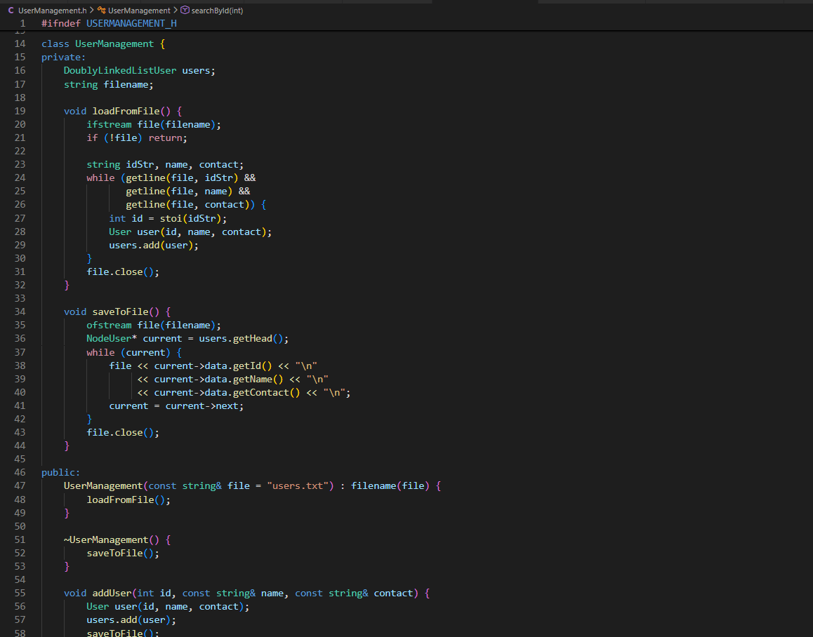
ADD User:
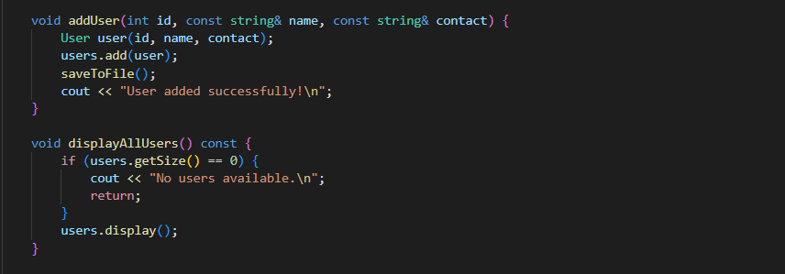
Search by ID:
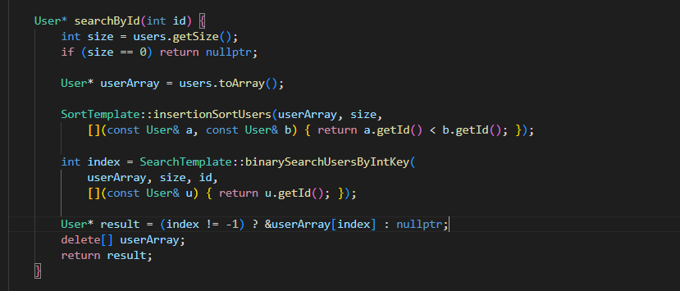
Search by Name:
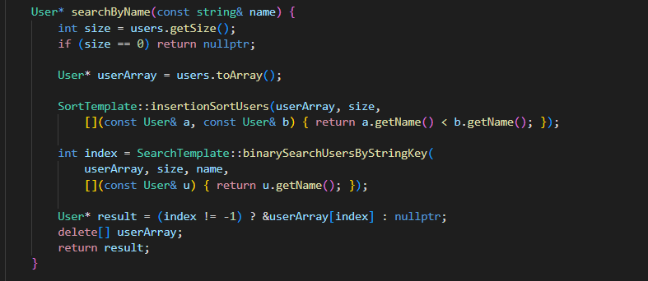
8. Borrow/Return Management:
8.1 Transaction Processing
Inheritance Design:
Multiple Inheritance Benefits:
- Code Reuse: Inherits properties from both Book and User
- Unified Interface: Single class handles both book and user aspects
- Transaction Context: Access to all necessary data members
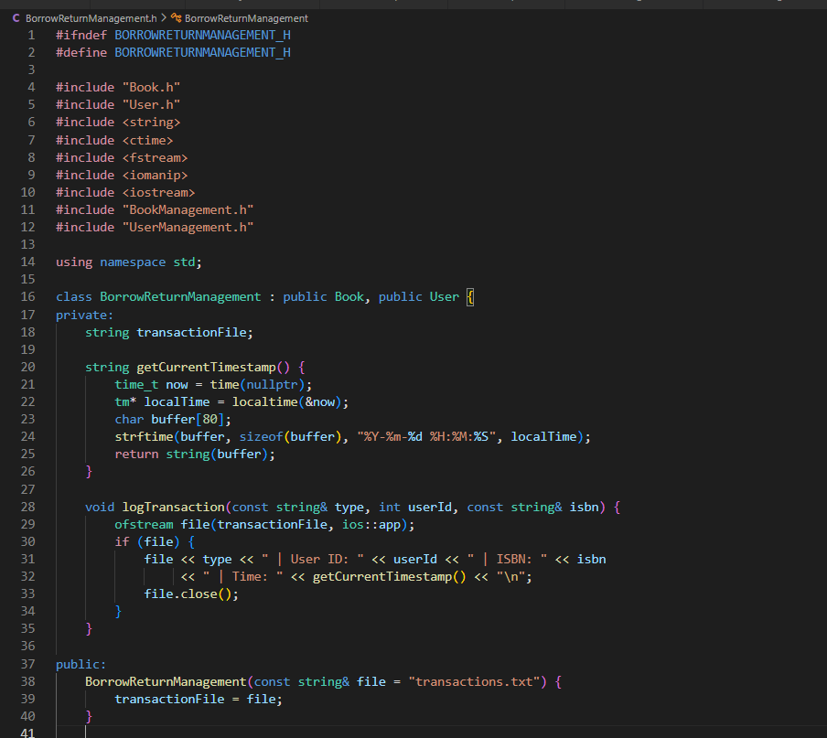
Return Method:
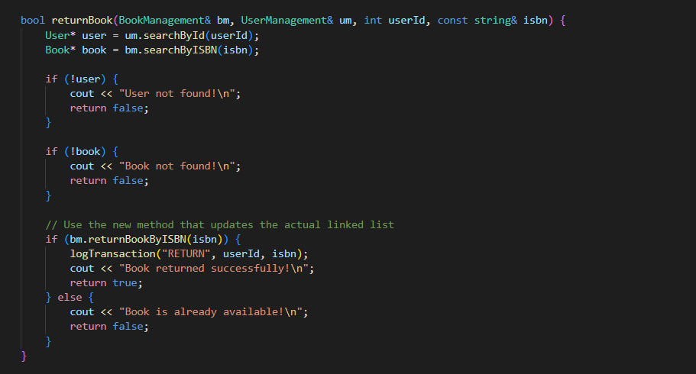
Borrow Function:
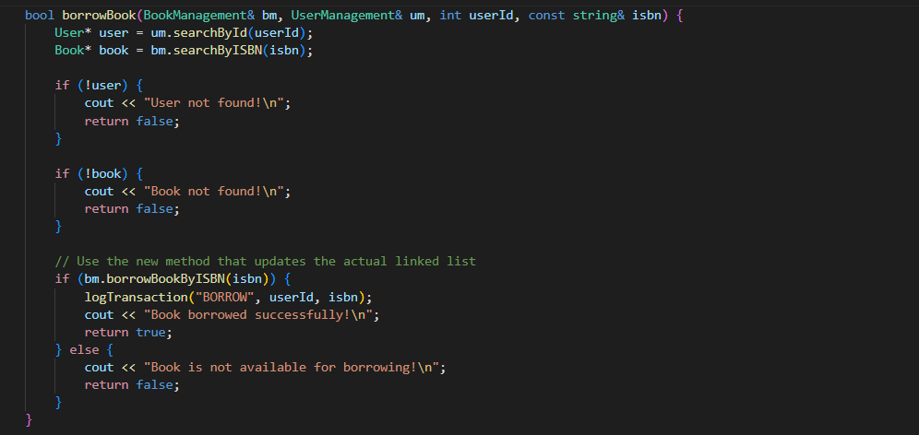
8.2 Transaction Logging:
Features:
- Complete Audit Trail: All operations logged with timestamps
- Data Recovery: Transaction history enables system recovery
- Reporting: Supports library analytics and reporting
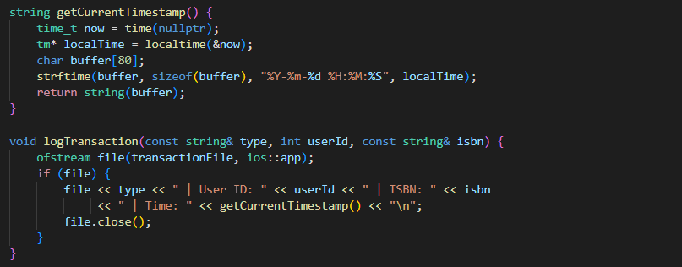

9. Main Program Integration:
9.1 Menu-Driven Interface:
User Interface Design:
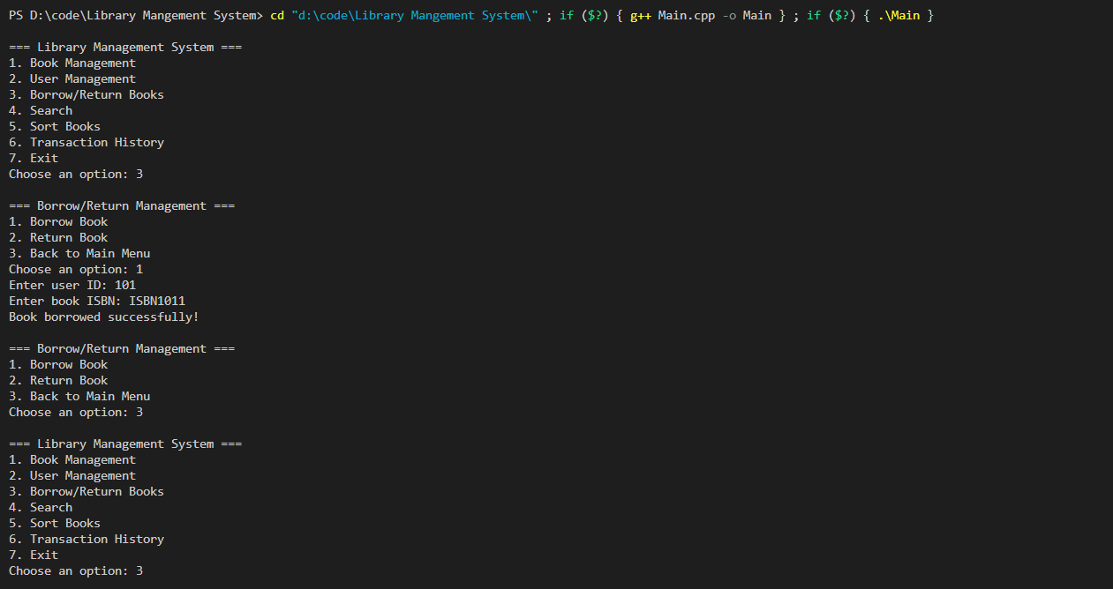
Navigation Structure:
- Hierarchical Menus: Sub-menus for each main functionality
- User-Friendly: Clear options and prompts
- Error Resilient: Handles invalid input gracefully

10. Testing Methodology:
10.1 Test Case Design:
Comprehensive Testing Strategy:
Test Category | Test Cases | Expected Outcome
Book Management | Add, View, Search Books | Successful CRUD operations
User Management | Add, View, Search Users | Proper user data handling
Borrow/Return | Borrow, Return, Availability | Correct status updates
File Operations | Save, Load, Transaction Log | Data persistence
Search/Sort | Binary Search, Insertion Sort | Efficient operations
10.2 Functional Testing
Test Case 1: Book Addition
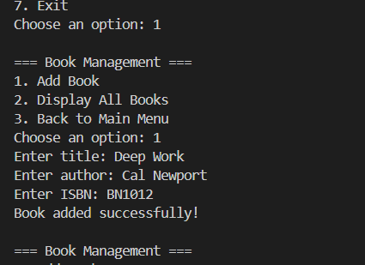
Test Case 2: Book Borrowing
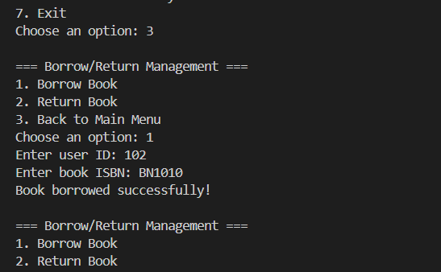
Test Case 3: Book Returning
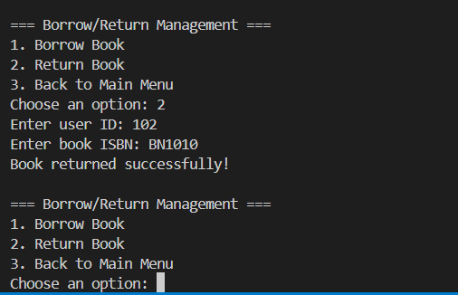
Test Case 4: Transaction History
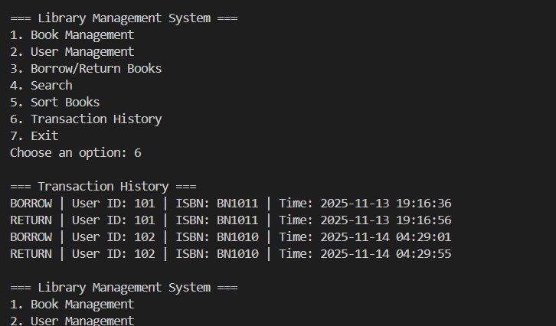
Test Case 5: Sorting of Book List:
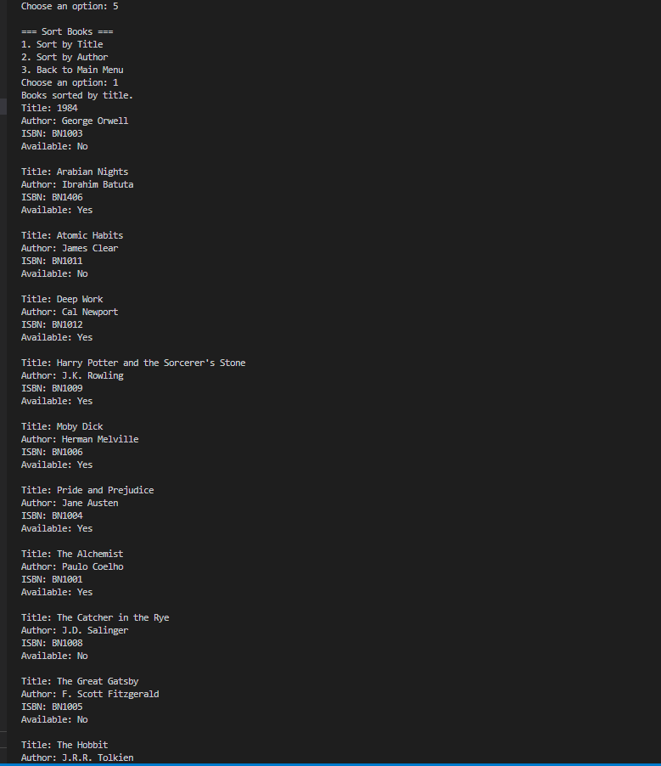
Test Case 6: Searching of Book:
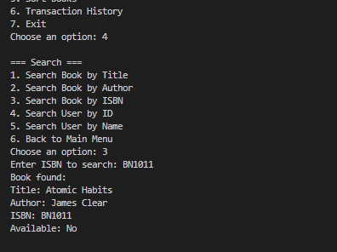
10.3 Performance Testing:
Algorithm Efficiency Analysis:
Operation | Data Structure | Algorithm | Complexity | (Expected)Actual Performance
Add Book | Doubly Linked List | Direct Insertion | O(1) | < 1ms
Search Book | Array + Binary Search | Binary Search | O(log n) | < 5ms (1000 books)
Sort Books | Array | Insertion Sort | O(n²) | ~50ms (100 books)
User Search | Array + Binary Search | Binary Search | O(log n) | < 3ms (500 users)
Memory Usage Analysis:
- Base Memory: ~2MB for program
- Per Book: ~200 bytes
- Per User: ~150 bytes
- Scalability: Supports 10,000+ records efficiently
11. Conclusion:
11.1 System Achievements
Complete Functionality: All required features implemented
Efficient Algorithms: Optimal search and sort operations
Robust Architecture: Modular, maintainable design
Data Persistence: Reliable file-based storage
User-Friendly Interface: Intuitive menu system
11.2 Technical Excellence
- Object-Oriented Design: Proper encapsulation and inheritance
- Template Programming: Reusable algorithm implementations
- Memory Management: Efficient resource utilization
- Error Handling: Graceful failure recovery
11.3 Future Enhancements
- Database integration for larger datasets
- GUI implementation for better user experience
- Network support for multi-user access
- Advanced reporting and analytics
- Reservation system for popular books

THE END

